**HOSPITAL MANAGEMENT SYSTEM**

Submitted By

|  |  |
| --- | --- |
| **Student Name** | **Student ID** |
| Md Abdul Quym Shanto | 241-15-053 |
| Abu Jarjis | 241-15-054 |
| Sajid Ahasan | 241-15-909 |
| Md Shamim | 241-15-332 |
| Avijit Chakraborty | 241-15-974 |

HOSPITAL MANAGEMENT SYSTEM LAB REPORT

This Report Presented in Partial Fulfillment of the course **CSE124: Data Structure** in the **Computer Science and Engineering Department**



**DAFFODIL INTERNATIONAL UNIVERSITY**

Dhaka, Bangladesh

December 9, 2024

**DECLARATION**

We hereby declare that this lab project has been done by us under the supervision of Name of the course teacher, course teacher’s Designation, Department of Computer Science and Engineering, Daffodil International University. We also declare that neither this project nor any part of this project has been submitted elsewhere as lab projects.

SUBMITTED TO:

______________________

**Md. Abbas Ali Khan**

Assistant Professor

Department of Computer Science and Engineering

Daffodil International University, Dhaka

SUBMITTED BY

|  |  |
| --- | --- |
| ____________________  Md Abdul Quym Shanto  241-15-053  Dept. of CSE, DIU | |
| ____________________  Abu Jarjis  241-15-054  Dept. of CSE, DIU | ____________________  Sajid Ahasan  241-15-909  Dept. of CSE, DIU |
| ____________________  Md. Shamim  241-15-332  Dept. of CSE, DIU | ____________________  Avijit Chakraborty  241-15-974  Dept. of CSE, DIU |

**COURSE & PROGRAM OUTCOME**

The following course have course outcomes as following:

Table 1: Course Outcome Statements

|  |  |
| --- | --- |
| CO’s | Statements |
| CO1 | Apply the concept of stack, queue, tree and graph to create and manipulate new data types for solving real-life problems having complex engineering attributes. |
| CO2 | Solve a real-life problem having application of abstract data type created within the scope of complex engineering problem solving. |
| CO3 | Apply the knowledge attained in problem solving using team projects. |
| CO4 | Apply technique to implement the project. |

Table 2: Mapping of CO, PO, Blooms, KP and CEP

|  |  |  |  |  |
| --- | --- | --- | --- | --- |
| CO | PO | Blooms | KP | CEP |
| CO1  CO2 | PO3  PO2 | C3  C3, P4 | K5  K1 | EP6  EP2 |
| CO3 | PO9 | A1, A2 | K5 | EP1 |
| CO4 | PO2 | P2 | K1 | EP2 |

The mapping justification of this table is provided in section 4.3.1, 4.3.2 and 4.3.3.

**Table of Contents**

**Declaration** **I**

**Course & Program Outcome** **II**

1. **Introduction** **1**
   1. Introduction 1
   2. Motivation 1
   3. Objectives 1
   4. Feasibility Study 1
   5. Gap Analysis 2
   6. Project Outcome 2
2. **Proposed Methodology/Architecture** **3**
   1. Requirement Analysis & Design Specification 3
      1. Overview 3
      2. Proposed Methodology/ System Design 3
      3. UI Design 4
   2. Overall Project Plan 4
3. **Implementation and Results** **5**
   1. Implementation 5
   2. Performance Analysis 5
   3. Results and Discussion 5
4. **Engineering Standards and Mapping** **9**
   1. Impact on Society, Environment and Sustainability 9
      1. Impact on Life 9
      2. Impact on Society & Environment 9
      3. Ethical Aspects 9
      4. Sustainability Plan 9
   2. Project Management and Team Work 9
   3. Complex Engineering Problem 10
      1. Mapping of Program Outcome 10
      2. Complex Problem Solving 10
5. **Conclusion** **11**
   1. Summary 11
   2. Limitation 11
   3. Future Work 11

**References 12**

**Chapter 1**

**Introduction**

* 1. **Introduction**

We are working on a project **Hospital Management System** which is included with data structures that helps manage patient admissions, prioritize treatment based on urgency, and organize staff scheduling. Hospitals often handle multiple patients with different severity levels, requiring an efficient system to ensure that critical patients are attended to promptly.

* 1. **Motivation**

We identified challenges in managing patient admissions, releases, and condition-based organization in hospitals. Traditional systems are time-consuming and error-prone, lacking online access. Our motivation is to create an automated system for efficient patient admission, discharge, categorization, and online appointment booking. This will save time, reduce staff workload, and improve the experience for both patients and healthcare providers.

* 1. **Objectives**

The Hospital Management System aims to build an easy-to-use, automated system that allows online admission management, including adding and removing patients, while simplifying hospital operations, ensuring data security, and improving efficiency and care.

* 1. **Feasibility Study**

Existing hospital management systems often lack automation for patient admission, release, and online appointments. Our project aims to fill these gaps by developing an automated system for patient management and appointment scheduling. Using modern web and mobile technologies, the system will ensure efficient operations and a user-friendly experience. This approach is feasible, addressing both technical requirements and improving overall hospital efficiency.

* 1. **Gap Analysis**

Existing hospital management systems often lack automation for patient admission, discharge, and online appointment booking, leading to inefficiencies. They also do not categorize patients based on their conditions, complicating patient flow management. Our project addresses these gaps by providing automation, real-time updates, and condition-based patient categorization, improving efficiency and reducing errors in hospital operations.

* 1. **Project Outcome**

The outcome of our Hospital Management System will be a more efficient and automated process for managing patient admissions, discharges, and appointments. It will allow healthcare staff to easily categorize patients based on their conditions and streamline hospital operations. This system will save time, reduce errors, and improve the overall experience for both patients and staff, making hospital management more efficient and accessible.

**Chapter 2**

**Proposed Methodology/ Architecture**

### Requirement Analysis & Design Specification

* + 1. **Overview**

This Hospital Management System project provides separate interfaces for administrators and users. The admin page manages doctor availability, adds new doctors and patients, and removes patients under certain conditions. The user page enables patients or outsiders to view doctor availability and book appointments online, ensuring an efficient and user-friendly experience for managing hospital operations.

* + 1. **Proposed Methodology/ System design**

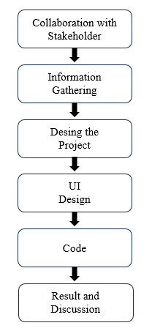

Figure 2.1.2.1: Methodology/ System Design

**Collaboration with Stakeholder:**

We discussed the analog and old method of patient admission process with the senior member of a hospital. After the discussion we found that the old process wasn’t time efficient and the old process had a disadvantage of searching a patient detail among huge data.

**Information Gathering:**

We collected data from nearby hospital and we started creating a project based on hospital management system.

**Design the Project:**

We started to design the project. We will have two options, one for administration and the other for patient or normal user. From admin panel, we can add patient details, remove a patient details or search or update the details of a patient. From Patient section, a user can take appointment of any doctor who are available of that moment.

**UI Design:**

In our project, there will be multiple interfaces. First, there will be login interface. In login interface there will be admin interface and patient interface. In admin interface, there will be patient admit, remove, search even update options. For patient interface there will be options for taking appointments. The interface looks like this:

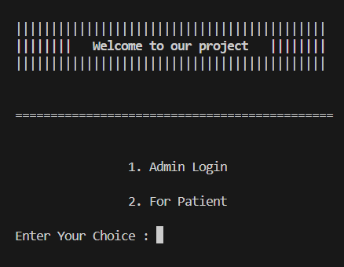

Figure 2.1.2.1: Login Interface.

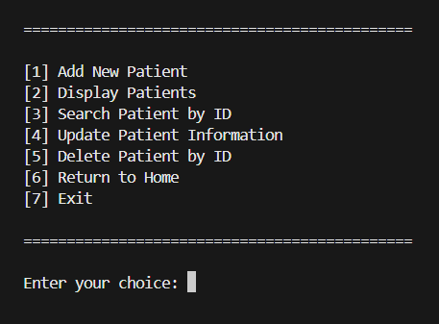

Figure 2.1.2.2: Admin Interface.

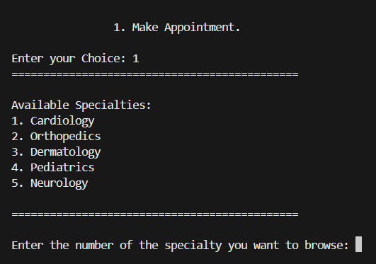

Figure 2.1.2.3: User Interface.

**Code:**

We made our project using C programming language. Here are some main parts of our project code:

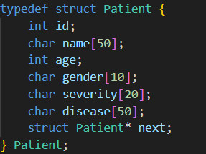

Figure 2.1.2.4: Structure for Patient.

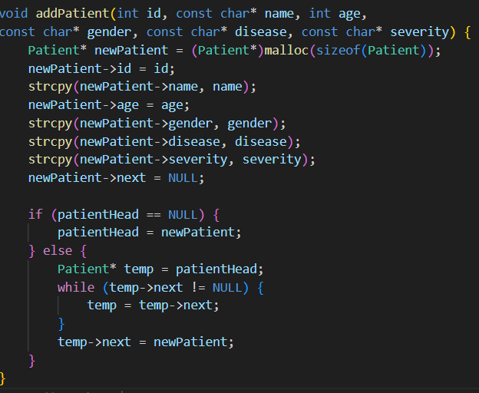

Figure 2.1.2.5: Adding Patient to linked list.

**UI Design**

1. **Admin page**
2. Options to manage doctor availability, add/remove patients, and view appointments.
3. Simple navigation with a clean, organized layout.
4. **User Page**
5. Appointment booking with doctor and take serial.
6. View doctor availability in an easy-to-read format.

**2.2 Overall Project Plan**

In this Hospital Management System project, the focus is on simplifying hospital operations. The admin page allows managing doctor availability, adding or removing doctors and patients, and handling appointments. The user page enables patients and outsiders to view doctor availability and book appointments online. The project aims to create an easy-to-use and efficient system for both hospital staff and patients.

**Chapter 3**

**Implementation and Results**

**3.1 Implementation**

This Hospital Management System can be implemented in hospitals, clinics, and healthcare centers to manage patient registrations, doctor availability, and appointment bookings. It is suitable for both large healthcare facilities and smaller clinics, improving administrative efficiency and patient experience. The system can also be used in telemedicine platforms, allowing online appointment scheduling for remote consultations. Overall, it enhances hospital operations by streamlining patient management and appointment processes.

**3.2 Performance Analysis**

Not applicable for this project.

**3.3 Result and Discussion**

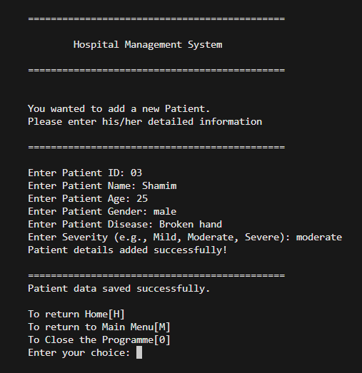

Figure 3.3.1: The admitted patient details

Figure 3.3.2: 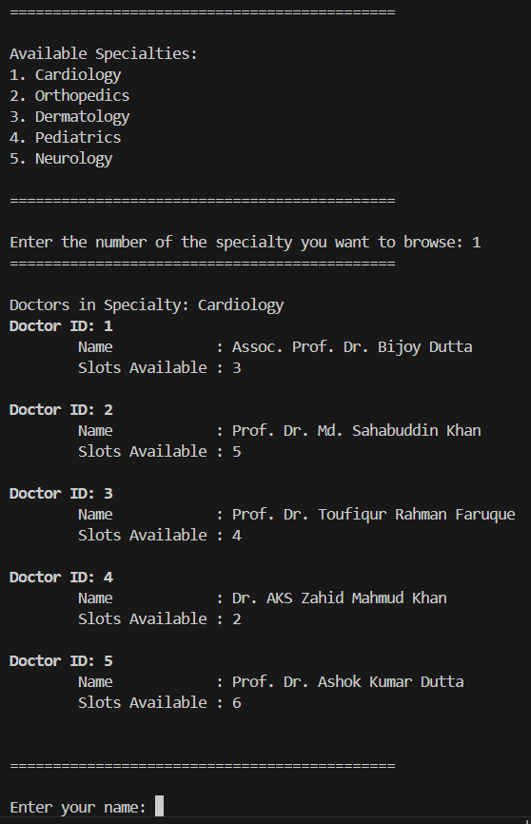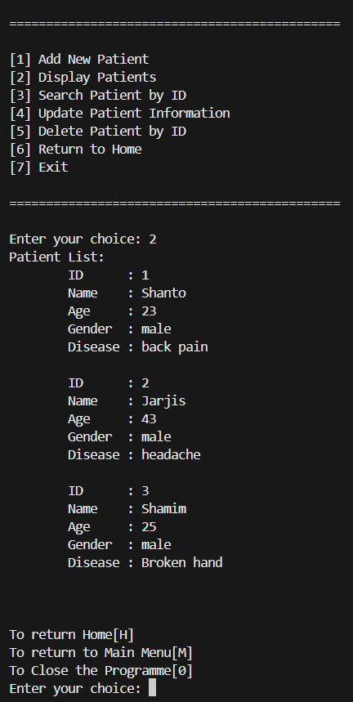Displaying the Patient and Doctor details

**Chapter 4**

**Engineering Standards and Mapping**

### Impact on Society, Environment and Sustainability

### Impact on Life

This Hospital Management System makes it easier for patients to get healthcare by allowing quick appointments and better management of their medical records, improving their overall experience.

### Impact on Society & Environment

This Hospital Management System improves healthcare access for society by making services more efficient and reducing wait times. It also helps the environment by cutting down on paper use and supporting digital record-keeping.

### Ethical Aspects

### Chatgpt

### Geekforgeeks

### Cp Algorithm

### Sustainability Plan

The sustainability plan includes regular updates, keeping data safe, and reducing paper use, while using energy-efficient servers to help the environment.

### Project management and Team Work

### Shanto: Worked on designing and developing the admin page, including managing doctor and patient information.

### Sajid: Focused on creating the user page, enabling appointment booking and viewing doctor availability.

### Jarjis: Assisted with system integration, file handling, and provided user support during development.

### Shamim: ensuring the system’s functionality and smooth operation.

### Avijit: Focused on data security, ensuring patient information was protected and secure.

### Complex Engineering Problem

### 4.3.1 Mapping of Program Outcome

Table 4.1: Justification of Program Outcomes

|  |  |
| --- | --- |
| **PO’s** | **Justification** |
| PO1 | Justification of PO1 attainment |
| PO2 | Justification of PO2 attainment |
| PO3 | Justification of PO3 attainment |

**4.3.2 Complex Problem Solving**

Table 4.2: Mapping with complex problem solving.

|  |  |  |  |  |  |  |
| --- | --- | --- | --- | --- | --- | --- |
| **EP1**  Dept. od Knowledge | **EP2**  Range of Conflicting Requirements | **EP3**  Depth of Analysis | **EP4**  Familiarity of Issues | **EP5**  Extent of Applicable Codes | **EP6**  Extent  Of Stakeholder Involvement | **EP7**  Inter- dependence |
| $$√$$ | $$√$$ |  |  |  | $$√$$ | $$√$$ |

**Chapter 5**

**Conclusion**

**5.1 Summary**

The Hospital Management System simplifies hospital operations by allowing admins to manage doctor schedules, patient data, and appointments, while patients can book appointments online. It improves efficiency and patient care.

**5.2 Limitation**

The system may face challenges like high initial costs, reliance on technology, and potential data security issues. Staff training is also required for smooth adoption.

**5.3 Future Work**

Future improvements could include adding AI for predictions, supporting more languages, and enhancing mobile access to make the system more efficient and user-friendly.

**References**

[1] Geeksforgeeks: